**Theodore Roosevelt Expressway Report**

**November**

**Ports-to-Plains Virtual Board Meeting**

The efforts to expand the Theodore Roosevelt Expressway to four-lanes continue to move forward. Progress is becoming evident along the corridor and with your support and membership contribution, we will continue to lobby for funding to complete our mission to have the Theodore Roosevelt Expressway a Four-Lane system.

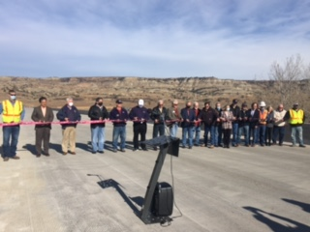Interesting times for sure? We had great progress along the Theodore Roosevelt Corridor in North Dakota, including the opening of the Long X bridge to a 4-lane structure. We continue to lobby for federal funding for transportation along the corridor (we have met with all the Congressional Delegations from North and South Dakota and Montana virtually) stressing the transportation funding needs for the corridor and rural America.

**New Long X Bridge Now Open:** The North Dakota Department of Transportation (NDDOT) and local officials celebrated the long-awaited opening of the new Long X Bridge to traffic on October 30, 2020!

NDDOT Director Bill Panos along with other state, federal and local officials were on hand for the ribbon-cutting ceremony for the new bridge. The project included a complete bridge replacement, highway construction and the addition of a wildlife crossing built under Highway 85 south of the bridge. The new bridge is a concrete girder bridge and has four, 12-foot driving lanes with a median in the center. The new bridge will accommodate larger, wider truck loads than was previously capable on the old bridge. “The state of North Dakota invested $37.4 million to transform the Long X Bridge into a safe and accessible passageway,” said Panos. “U.S. Highway 85 and this bridge are essential to transportation movement in western North Dakota.”

U.S. Highway 85, in North Dakota, continues to see significant Oversize/Overweight Permitted Load when compared to four-lanes highways in North Dakota.

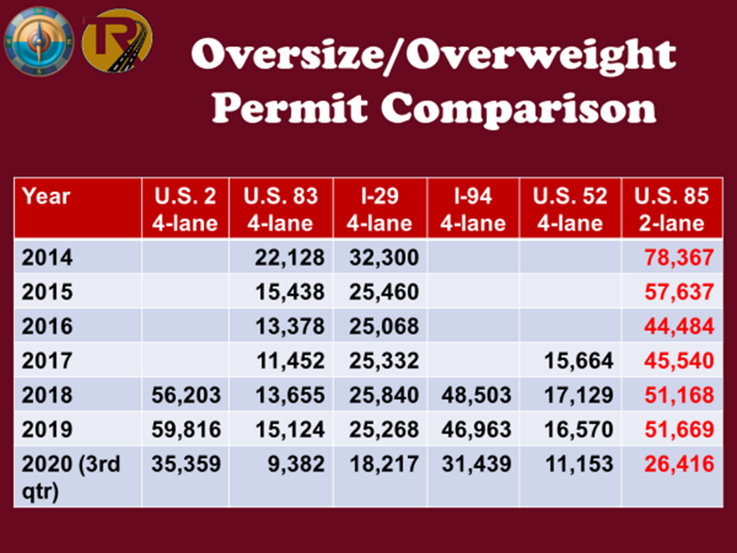

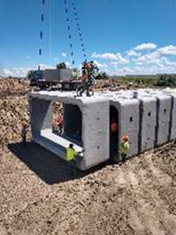In South Dakota, U.S. Highway 85 between Belle Fourche to Ludlow, a 70 miles segment, is receiving an asphalt overlay with paved shoulders in the last five years. Thirty-fives miles was completed in 2020 with a few miles scheduled to be completed in 2021 due to winter’s arrival. From Ludlow to South Dakota/North Dakota state line on U.S. Highway 85, the first ten miles south of the state line is scheduled for a mill and asphalt overlay in 2025. Continuing south a grading project which will improve the grade line, pipe replacement, flatten the inslopes, improve sight distance, and add one northbound and one southbound passing lane is scheduled for 2028. The long-range plan would add passing lanes at approximately ten-mile intervals, including five northbound and five southbound. We hope that a new developing relationship with Elevate Rapid City will impact the plans for South Dakota to begin planning the four-lane divide.

For U.S. Highway 2 in Montana, between Culbertson and Bainville, a project was completed this fall at a cost of approximately $18 million which reconstructed the highway with two 12-foot driving lanes ad 8-foot shoulders. Between Bainville and the Montana/North Dakota state line, Phase II which would add two lanes, creating a mostly divided four-lane profile has completed design and it awaiting a funding source. The estimated cost of Phase II is $26 million.