Theodore Roosevelt Expressway
1st Quarter 2022

The Theodore Roosevelt Expressway 4 lane project is going SOUTH!!!!

Watford City to the Long-X Bridge Right of Way acquisition has started and should be complete sometime in the summer of 2022. Once the acquired necessary right-of-way is acquired, the North Dakota Department of Transportation (NDDOT) will move forward with relocating utilities that are in the way. Many times, utilities are located on the back side of right-of-way, which is why NDDOT is waiting on the movement of utilities. NDDOT anticipates utilities should be done by fall of 2022. NDDOT is planning to bid the project in the fall of 2022 or early spring of 2023. We should see some dirt moving on this stretch in 2023.

Long-X Bridge to Hwy 200 NDDOT will need to bring on a consultant to work on designing this next stretch and are planning to have a request for proposal to do this work the first week in December of 2021. This piece of the 4-Lane project has been particularly challenging. It is great to see progress soon. (NDDOT) is applying for a Rebuilding American Infrastructure with Sustainability and Equity (RAISE) grant application for the Theodore Roosevelt Expressway Freight Expansion Project. Many Letters of support for this grant have been submitted from TREA membership, North Dakota State legislators, Governor Burgum, and the North Dakota Congressional Delegation.

The Theodore Roosevelt Expressway Association (TREA) has been working closely with NDDOT to assist in funding these projects along with the State Legislature’s and Federal Delegations. The recently passed Bipartisan Infrastructure Law is the largest long-term investment for our infrastructure and competitiveness in nearly a century. The need for action in North Dakota is clear, and recently released state-level data demonstrates that the Bipartisan Infrastructure Law will deliver for North Dakota.

Other projects planned along the corridor for the summer of 2022 in North Dakota is a Safety corridor project from Belfield to Jct. ND 200 on the Theodore Roosevelt Expressway (TRE) with some enhanced striping and signing. A turn lane coming off U.S 85 (TRE) at the gas plant south of Belfield and turn lanes, lighting, and chip seal through Belfield.

In terms of Oversize/Overweight Permitted Loads, below is the Updated Final Comparison for 2021, Updated 2022 data is attached.
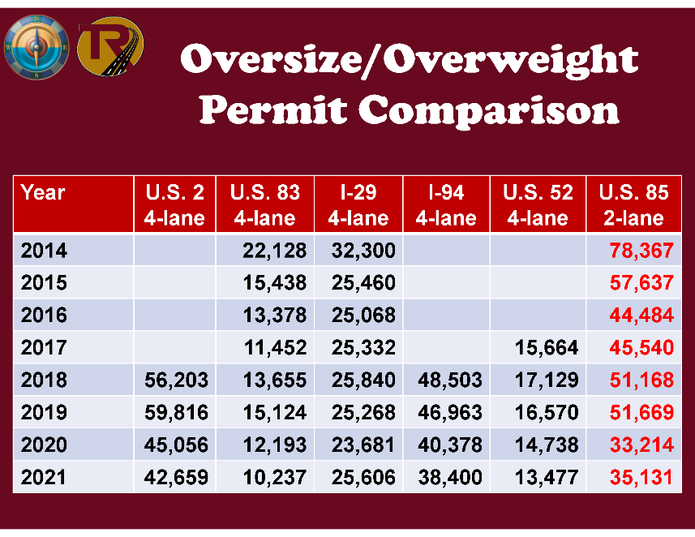

Additionally, TREA is pulling data from the segments of U.S. 85.

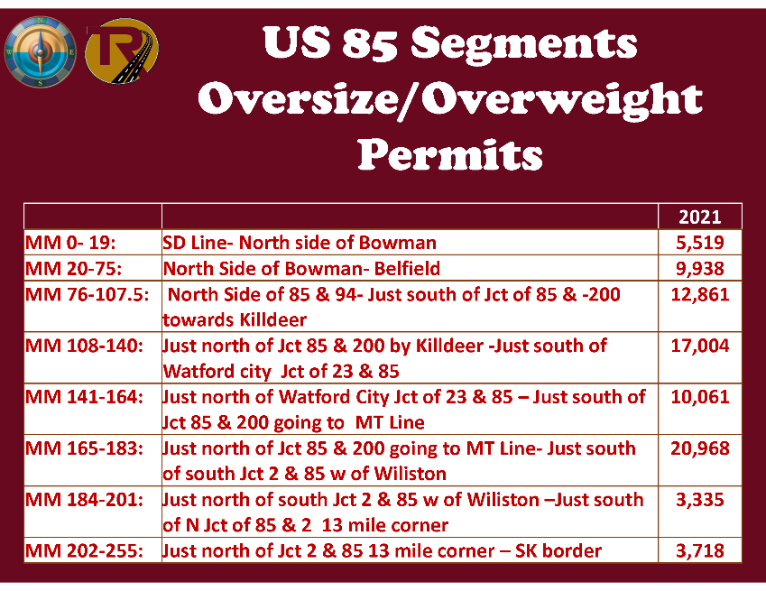

On behalf of the Board of Directors of Theodore Roosevelt Expressway Association (TREA), we appreciate your continued support!!!

Thank you,

Cal Klewin
Executive Director, Theodore Roosevelt Expressway Association
701.523.6171 cal@trexpressway.com

