

**2017 4rd Quarter report**

The Theodore Roosevelt Expressway Association (TREA) is looking to 2018 as a positive year for progress on the corridor in the TREA states and the Ports to Plains Alliance. We will continue to lobby for Transportation funding for the corridor at the federal, state and local levels. We are scheduled to visit Washington D.C the week of April 16-20, 2018 to stress the importance of funding transportation corridors as the Theodore Roosevelt Expressway and the Ports to Plains Alliance States. We have good success in developing a Ports to Plains Caucus with Congressional members to support Rural Transportation Issues and the development of the Ports to Plains Corridor. I have listed the members that have signed on to date;

**Representatives: Arrington (TX co-Chair), Smith (NE co-Chair), Cuellar (TX co-Chair), Gonzales (TX co-Chair), Cramer (ND), Buck (CO),**

**Senators Fischer (NE co-Chair), Heitkamp (ND co-Chair), Cornyn (TX), Hoeven (ND), Gardner (CO) Daines (MT)**

If anyone has an interest in attending the D.C. Fly-In with us please mark your calendar (April 16-20, 2018) and let me know of your interest.

The Theodore Roosevelt Expressway Association (TREA) attended and gave dinner presentations to the Multi- State Township Officer’s Annual Meeting; states represented were Wisconsin, Minnesota, North Dakota, and South Dakota, in Grand Forks, North Dakota. In December to the North Dakota Township Officers Annual meeting in Bismarck, and the Western Dakota Energy Alliance Annual meeting in Dickinson North Dakota. The presentation’s highlighted the importance of transportation and trade along the Ports to Plains corridor to enhance economic development opportunities.

Below are the end of year 2017 over sized over weight over height permitted load comparison’s traveling major North South corridors in North Dakota, submitted to the Theodore Roosevelt Expressway Association.  Thanks to the North Dakota Highway Patrol for this information.

Permit Numbers show an increase in Western North Dakota oversized load freight activity in 2017.

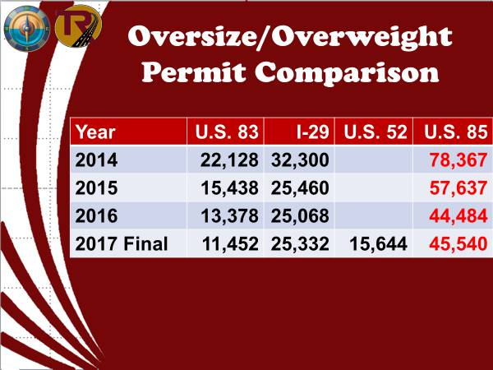

   We hope to access Oversized Permitted load #s from other Alliance states to develop a correlation of transportation freight movements and connectivity along the corridor.

US 85 on the Theodore Roosevelt Expressway was included in a large truck primary highway network approved by the North Dakota legislature. Permitted vehicle weights on the network increase to129,000 pounds.   North Dakota legislature approved more than $500 million for four lanes and replacement of the Long X Bridge on the Theodore Roosevelt Expressway.

Planning continues the Watford City to I-94 Phase of the Theodore Roosevelt Expressway,

Continuing working on the Draft EIS for the US Highway 85 project. In February/March we will be advertising for the Notice of Availability of the Draft EIS and advertising for public hearings.

If you or an organization you are aware of, that would like to have an update of the TREA progress and Ports to Plains activities please contact us and we will do our best to accommodate.

**In closing I ask you to keep our Theodore Roosevelt Expressway Association President Gene Veeder in your thoughts as he recovers from a setback with his health.**

Cal Klewin

Executive Director

Theodore Roosevelt Expressway Association.

701.523.6171

cal@trexpressway.com

[www.trexpressway.com](http://www.trexpressway.com)