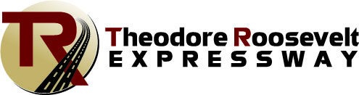
PO Box 1306.
Williston, ND 58802-1306
701.523.6171 701-577-8110
cal@trexpressway.com . www.trexpressway.com

Theodore Roosevelt Expressway Association
Breaking News/ Old News?!!
FHWA has signed the Final Environmental Impact Statement & Record of Decision (final environmental document) for the US 85 – I-94 at Belfield to Watford City Bypass expansion project.

NDDOT is working to create the final electronic document, publish a notice of availability in the Federal Register, and provide public notification of the final document. It is expected that the official notice of availability and statute of limitations will be published in the Federal Register on March 15th.

Thank you to everyone contributed to this challenging and exciting project!

NDDOT will continue the discussion on when exactly to bid the Long X Bridge project (Spring 2019)

The Theodore Roosevelt Expressway Association has been working with the North Dakota Legislature on several transportation funding issues including gas tax increase that has failed. It is concerning how we fail to properly fund our transportation system at the state and federal level, any ideas? One of the bills that may assist in funding and provide matching funds for the North Dakota Department of Transportation (NDDOT) is moving forward in the North Dakota Senate SB2268, Corridors of Commerce. The bill provides funding from the Bank of North Dakota using a bonding mechanism for NDDOT projects. The Corridor of Commerce bill has been very well received so far and was supported by the NDDOT in the Senate Transportation Committee hearing, along with Energy and Transportation interests testifying in favor, there was no opposing testimony at the Senate transportation committee hearing. SB 2268 has passed the full Senate 47-0 and moved on to House Appropriations on March 11,2019 .
Below is a summary of the bill details:
Corridors of Commerce program. NDDOT shall administer a corridors of commerce program for constructing, reconstructing, improving, and maintaining highways that improve freight transportation and facilitate commerce. The corridors of commerce fund is a special fund in the state treasury administered by the department. Pursuant to legislative appropriations, the department shall use moneys in the fund for eligible highway projects in accordance with provisions of this section. To be eligible for funding under this section: a. any construction work associated with the project must begin within three years after the department selects the project for funding, unless the department grants an exemption. The highway project must meet at least one of the following criteria:
(1) The project is a segment of highway with the following characteristics:
(a) The existing segment is not a divided highway;
(b) At least one end of the segment connects to an expressway or freeway; and
(c) The segment will connect to a proposed or existing interchange;
(2) The project will ease the movement of freight traffic;
(3) The project will improve safety on the highway;
(4) The project will allow oversized or overweight vehicles to use the highway after completion;
(5) The project will provide increased connectivity between areas of significant commerce; or
(6) The highway is or will be designated as national high priority corridor of connectivity.

When evaluating eligible projects for funding under this section, the department shall score each eligible project, make the scores available to the public, and consider:
(a) The return on investment;
(b) Measurable improvements in commerce and economic competitiveness;
(c) Efficiency in traffic flow based on average daily traffic counts; commercial vehicle miles traveled, and travel times;
(d) Safety improvements;
(e) Connections to regional trade centers or other modes of transportation; and
(f) Community support for the project.
The funding provided to an eligible highway project may be used to plan, construct, replace, improve, or maintain the highway. The North Dakota Department of Transportation will be applying for the 2019 INFRA Grant Opportunity for the northern part of the Highway 85 (TRE) Freight Expansion Project. This project is converting the two-lane route into a four-lane mostly divided highway from south of Watford City to the Long X Bridge.
Construction work in Belfield is proposed to begin in 2019 will also include safety improvements to Highway 85 through the community. The North Dakota DOT project will add a turning lane and pedestrian crossing in the high traffic area near the gas stations and restaurants
The Theodore Roosevelt Expressway Association (TREA) continues to track the overweight, oversize, permits issued every quarter for various major freight corridors in North Dakota, and the numbers for U.S.85 continue to be at the top of issued oversized permitted loads in the State. The latest freight traffic numbers from the quarterly load report continues to support the need to four-lane Highway 85 from Watford City to I-94 at Belfield N.D. (The Theodore Roosevelt Expressway).
Highway 85 continues to carry oversized loads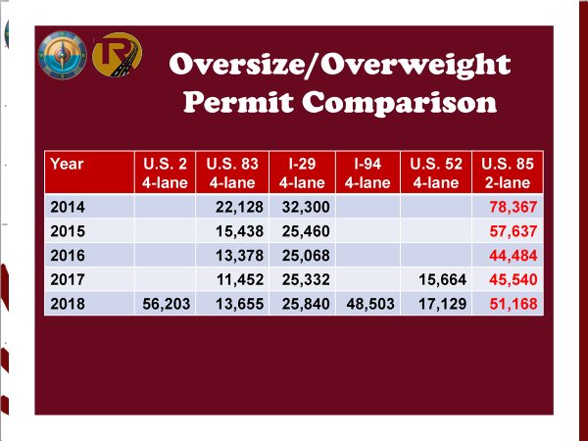
If you or an organization you are aware of would like to have an update or presentation of the TREA progress and Ports-to-Plains activities, please contact us and we will do our best to accommodate.
Cal Klewin
Executive Director
Theodore Roosevelt Expressway Association.
701.523.6171 cal@trexpressway.com

