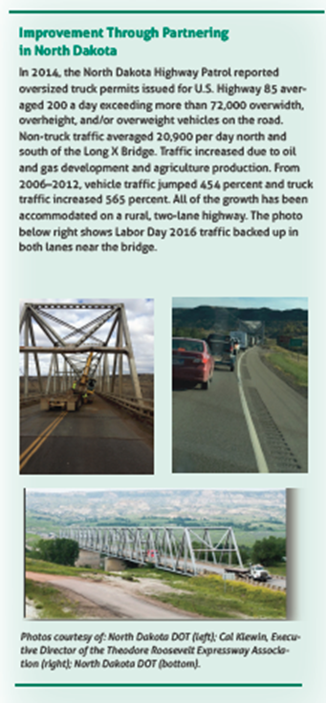

2016 4th Quarter report

The efforts to expand the Theodore Roosevelt Expressway continue to move forward. The North Dakota Department of Transportation (NDDOT) continues the U.S. 85 – I-94 to Watford City Bypass Environmental Impact Statement (EIS). This EIS included the replacement of the Long X Bridge.
In relationship to the EIS, the North Dakota Department of Transportation has indicated that all field studies for the EIS have been completed. Public scoping meetings have been held and a Purpose and Need Statement has been developed for the project. Alternative development and preliminary design is underway and Alternative Public Workshops have been held for the project. Additional stakeholder outreach is ongoing, as well as finalizing technical reports, alternatives, impact analysis, and document writing.
The NDDOT recently applied for the second round of FASTLANE Grants with the United States Department of Transportation to assist in funding a portion of the Long X Bridge replacement. The estimated cost is $60 million and the NDDOT is requesting $36 million in FASTLANE funds for construction costs.
Following the first round of FASTLANE applications, a NDDOT debrief with the FASTLANE program coordinators at USDOT indicated that, in the first round application (April 2016), the Long X Bridge FASTLANE application was one of 123 projects placed on the Secretary’s List of Projects to Consider. There were 212 total projects submitted last round, so that amounted to the application being in the top 58%. NDDOT has made adjustments to this application from that discussion, mostly in the environmental and benefit cost analysis sections. NDDOT also included a statement regarding the mention of this project in the “State of Freight II: The FAST Act and Beyond” report. See graphic on the first page.
Graphic from State of Freight II: The FAST Act and Beyond by AASHTO and AAPA

Construction on the Lewis and Clark Bridge is moving into its third year and will be the final connection of the expansion of U.S. Highway 85 from Watford City to Williston.
While activity on U.S. 85 has slowed with the economy, its significant role in North Dakota in the movement of permitted loads continues when compared to other north-south routes in North Dakota. As you can see in the graphic below, U.S. 85 continually leads by a significant margin in permitted overweight, over height, and over length loads.

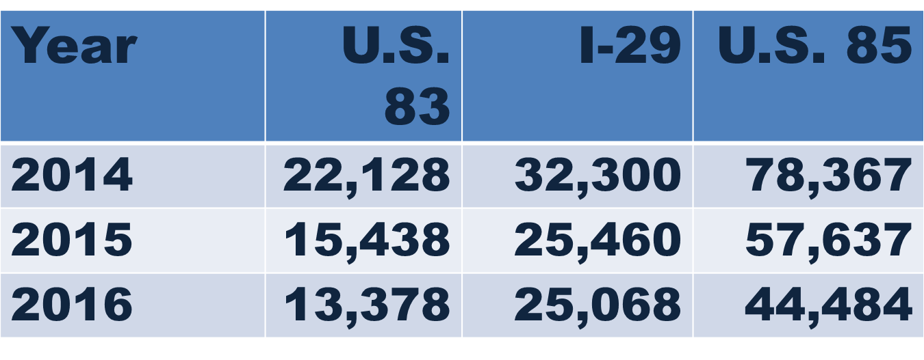
The Theodore Roosevelt Expressway Association continues to work with state and federal officials to promote highway infrastructure and is very pleased at the passage of a long-term, five-year Federal Transportation authorization called Fixing America’s Surface Transportation FAST Act.
In 2017, with the potential of a $1 trillion infrastructure concept being proposed by President-elect Trump, our combined voice will be very important in assuring the North Dakota and other rural areas of American will benefit from the concept as it moves to plan. We intend to join the Ports-to-Plains Alliance in messaging that if the infrastructure plan is limited to private dollars requiring payback through tolling that there will be no benefit to rural America.
Our work continues to complete the corridor with our alliance partners to provide safe efficient transportation for the traveling public. If you or an organization you are involved with, have any questions or would like update of the activities of the TREA please contact me, we will be happy to provide a presentation or update.
We are spending time at the North Dakota Legislature continuing to carry the message of the importance of surface transportation and the role it plays in economic development along the corridor.
We will be visiting the corridor Congressional Delegations with our message during our staff visit’s in March and the Annual D.C. Fly In later in the spring of 2017.

Thank you,

Cal Klewin
Executive Director Theodore Roosevelt Expressway Association
701.523.6171
cal@trexpressway.com

